CORRELATION ANALYSIS
-- Correlation analysis in Python is a way of measuring the relationship between two numerical variables—specifically, whether they tend to move together and how strongly.
-- Correlation specifically examines the strength and direction of a numerical-to-numerical relationship.
-- A strong correlation tells you that two variables move together; it doesn't establish that one causes the other.
-- For example, in your Kenya SACCO credit-risk project, you might ask:
- Does monthly income increase as loan amount increases?
- Is debt-to-income ratio related to default risk?
- Does credit score tend to decrease as previous defaults increase?

THE CORRELATION COEFFICIENT
-- The most commonly used measure is Pearson correlation, which produces a value between -1 and +1:
Correlation | Meaning
+1 | Perfect positive relationship
+0.7 | Strong positive relationship
+0.3 | Weak/moderate positive relationship
0 | No linear relationship
-0.3 | Weak/moderate negative relationship
-0.7 | Strong negative relationship
-1 | Perfect negative relationship

-- For example if an increase in Income causes an increase in Loan Amount, that would give a positive correlation. For example a 0.72 would be interpreted as Income and loan amount have a relatively strong positive linear relationship.
-- If an increase in Debt-to-Income Ratio causes a decrease in Credit Score, that would generally represent a negative correlation.

CORRELATION MATRIX
-- If you want to examine relationships among many numerical columns:
-- The diagonal is always 1.00 because each variable is perfectly correlated with itself.

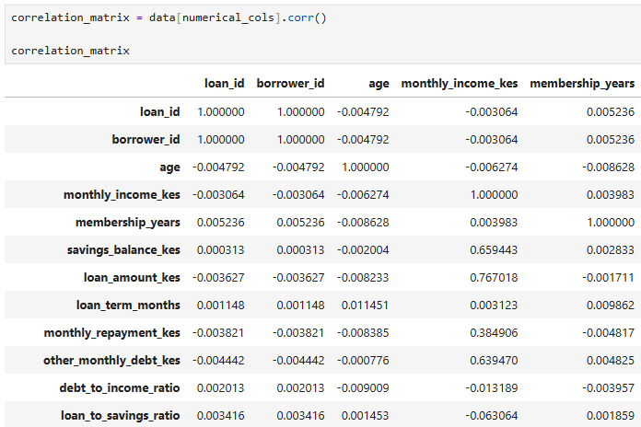

-- Pay special attention to:
default ↔ previous_defaults
default ↔ previous_late_payments
default ↔ monthly_income_kes
default ↔ loan_amount_kes
default ↔ other_monthly_debt_kes
default ↔ savings_balance_kes
Variable | Correlation with default | Direction | Strength | Business interpretation
Loan amount | +0.0497 | Positive | Very weak | Larger loans are associated with a slightly higher tendency toward default, but the relationship is very weak.
Previous defaults | +0.0378 | Positive | Very weak | Borrowers with more previous defaults tend to have slightly higher default values, but the linear relationship is very weak.
Previous late payments | +0.0112 | Positive | Extremely weak | More previous late payments show a tiny positive association with default in this dataset.
Monthly income | −0.0078 | Negative | Extremely weak | Higher income is associated with a slightly lower default tendency, but practically there is almost no linear relationship here.
Other monthly debt | +0.0100 | Positive | Extremely weak | Higher existing debt is associated with a tiny increase in default tendency, but the relationship is almost nonexistent linearly.
Savings balance | −0.1343 | Negative | Weak | Higher savings are associated with lower default. This is the strongest relationship among these variables, although it is still relatively weak.

default ↔ previous_defaults
-- A correlation of +0.0378(very weak) means borrowers with a higher probability of defaulting tend to have a higher number of previous defaults/ have defaulted many times before.
default ↔ previous_late_payments
-- A correlation of +0.0112(extremely weak) means borrowers with a higher default probability have a higher chance of having made late payments before or borrowers who have had many late payments before have a higher probability of defaulting. But the relationship is too weak to conclude that loan amount alone is a strong indicator of default risk.
default ↔ monthly_income
-- A correlation of −0.0078(extremely weak) means that borrowers with a higher monthly income tend to have a lower default probability(non-defaulters) but there is essentially no linear relationship between defaults and monthly income

default ↔ loan_amount
-- A correlation of +0.0497(very weak) means larger loan amounts show a positive association with higher default probability but the relationship is too weak to conclude that loan amount alone is a strong indicator of default risk.

default ↔ other_monthly_debt
-- A correlation of +0.0100(extremely weak) means borrowers with a higher default probability have a higher chance of having other monthly debts or borrowers with higher other monthly debts have a higher probability of defaulting. But the relationship is too weak to conclude that loan amount alone is a strong indicator of default risk.
default ↔ savings_balance
-- A correlation of −0.1343 means the two variables move in opposite directions.So you can interpret it from either direction Borrowers with higher savings tend to have lower default values. Or Borrowers with higher default values tend to have lower savings balances.
-- The negative correlation between savings balance and default (-0.1343) suggests that borrowers who default tend to have lower savings balances, while borrowers with higher savings tend to be associated with non-default. However, the relationship is weak, so savings alone is not a strong predictor of default.

CONCLUSION.
The correlation analysis indicates generally weak linear relationships between the numerical borrower/loan characteristics and default. Savings balance has the strongest observed relationship, with a weak negative correlation (-0.134), suggesting that borrowers with higher savings tend to have lower default risk. Loan amount and previous defaults show weak positive relationships, while previous late payments, other monthly debt, and monthly income show relationships very close to zero. Therefore, none of these variables individually demonstrates a strong linear relationship with default, although some may still contribute useful information when combined with other variables in a predictive model.

